**N1**

**N2**

**N3**

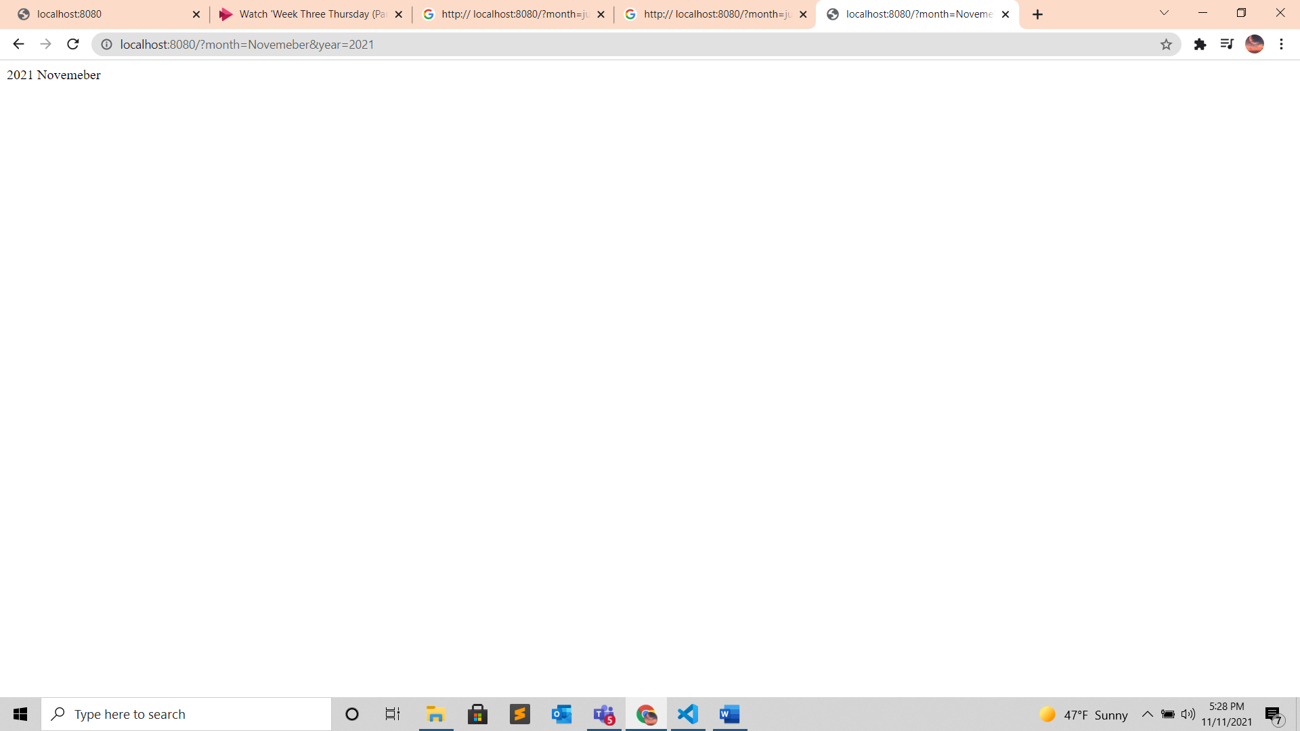

**N4**

Work environment :

